Supply Ontario

# User Guide

## VENDOR REPORTING PORTAL ON-LINE

Contents

VENDOR REPORTING ON-LINE - 4 -

Monthly Reporting Deadline - 4 -

How We Contact You - 4 -

Entering the Portal - 4 -

Need Assistance? - 5 -

Menu Items of Vendor Reporting Portal - 5 -

Contact-VOR Info - 5 -

Choose a Contact to View - 5 -

Edit a Contact’s Information - 6 -

To Add a New Contact - 6 -

To Delete a Contact - 6 -

Contact Personal Information Data Fields - 6 -

The Contact-VOR Section - 7 -

Adding Responsibility/Role - 8 -

Removing Responsibility/Role - 9 -

Vendor Info - 9 -

Submit Report - 10 -

Download Template - 11 -

Submit Reports - 11 -

Receipt - 12 -

Reports History - 12 -

Review History - 12 -

Reset Password - 13 -

Appendix - 14 -

Step by Step Guides for Vendor Reporting Portal - 14 -

Basic Reporting Concepts: - 14 -

For Submitting Reports: - 14 -

For Adding an Account (New Contact): - 14 -

For Editing Contact Information: - 15 -

For Deleting and Adding Contact VOR Responsibilities (Role): - 15 -

Removing VOR Responsibility (Role): - 15 -

Adding VOR Responsibility (Role): - 15 -

For Changing VOR Responsibility (Role): - 16 -

For Archiving (Deleting) a Vendor Contact: - 16 -

## VENDOR REPORTING ON-LINE

[This Vendor Reporting Portal](http://www.doingbusiness.mgs.gov.on.ca/mbs/psb/vordb.nsf) has been created to allow Province of Ontario Vendors of Record to facilitate their **submission of reports** when they get new contracts with the government and to allow Vendors to add or update **contact information** for use by Supply Chain Operations (SCO) staff and Ontario Public Service (OPS) clients.

### Monthly Reporting Deadline

The deadline for submitting all vendor reports is the 10th business day of the month following the reporting period (example: the deadline of submission for the January vendor report would be the 10th business day of February).

**Attention**: For each new transaction e.g., Purchase Orders (PO) or Statements of Works (SOW)) users are required to submit a Usage Report for the **entire value** of the contract once. Should there be an extension to an existing contract, vendors are required to submit a Usage Report for the extension value only. In months with **no new contract(s)** vendors are required to submit a NIL Report for that month.

### How We Contact You

It is important that users keep contact information for your organization **up to date** on this Vendor Reporting Portal, as this information will be the most current way for SCO staff and your OPS clients to communicate to you.

### Entering the Portal

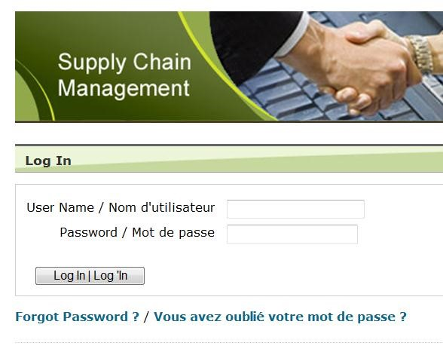Click on the [Vendor Reporting Portal](https://www.doingbusiness.mgs.gov.on.ca/mbs/psb/vordb.nsf/english/home_page?openDocument&login) to go to the portal.

Each Vendor of Record contact has been assigned a User-ID and a temporary password, and this data is sent to the Vendor users by email. It is the responsibility of the Vendor user to **change the temporary password and keep the new password secure**.

**Only Power Users may change the passwords of a vendor’s contacts** for their organization**.** For more information on Power Users, see the Contact-VOR Info Page section.

If you have forgotten your password, select the “Forgot Password” link on the left side of this Vendor reporting Portal page, and provide your Vendor’s User-ID and default email address to change your current password.

### Need Assistance?

Should you need help in accessing or using this website, please send an email to the [Vendor Reporting Administrator.](mailto:ppitpb.apts@ontario.ca)

## Menu Items of Vendor Reporting Portal

Menu items on the top left side of the Vendor home page on the Vendor Reporting Portal.

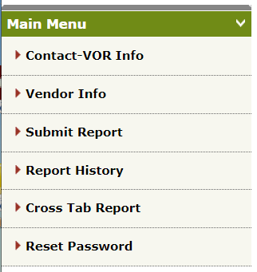

## Contact-VOR Info

This link on the menu items of the Vendor Reporting Portal page is used to assign a Vendor user(s) for reporting and update existing contact information or add new contact information for your organization to do vendor reporting.

### Choose a Contact to View

The **Select Contact** **View** lists all the contact names for your organization currently in the database. Click on one of the Vendors contacts on this list to view and edit this specific vendor contact data on the fields following below. If you wish to add a new contact to this list, click on the **Add New Contact** button.

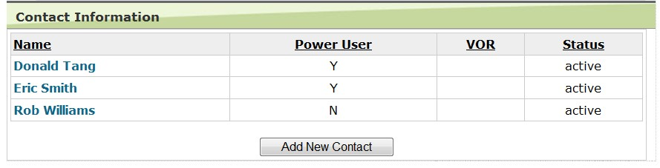

OSS

-

00195472

OSS

-

00172018

OSS

-

0195390

### Edit a Contact’s Information

At the bottom of the vendor contact’s information, click on the **Edit** button. After the page refreshes to the Edit View, change whichever data field(s) that need to be updated and press the **Save** button on the bottom of the web page. Remember to also update Vendor Of Record (VOR) responsibility and roles on the Contact-VOR section.

### To Add a New Contact

Either click the **Add New Contact** buttonon the Select Contact View page, or select a contact, click **Edit**, and then click **Add New Contact**. Remember to click **Save** after filling in the vendor contact details and add the VORs and roles that the contact is responsible for.

### To Delete a Contact

Select the contact to be deleted and click **Edit**. The **Edit View** page will show the **Change Status** field, select the **Archived** radio button, and press **Save**. This will remove the contact from the contact list.Please note that you will be unable to delete a contact if it is assigned a VOR responsibility (Reporter/Main). You must first delete the role(s), and then the contact.

## Contact Personal Information Data Fields

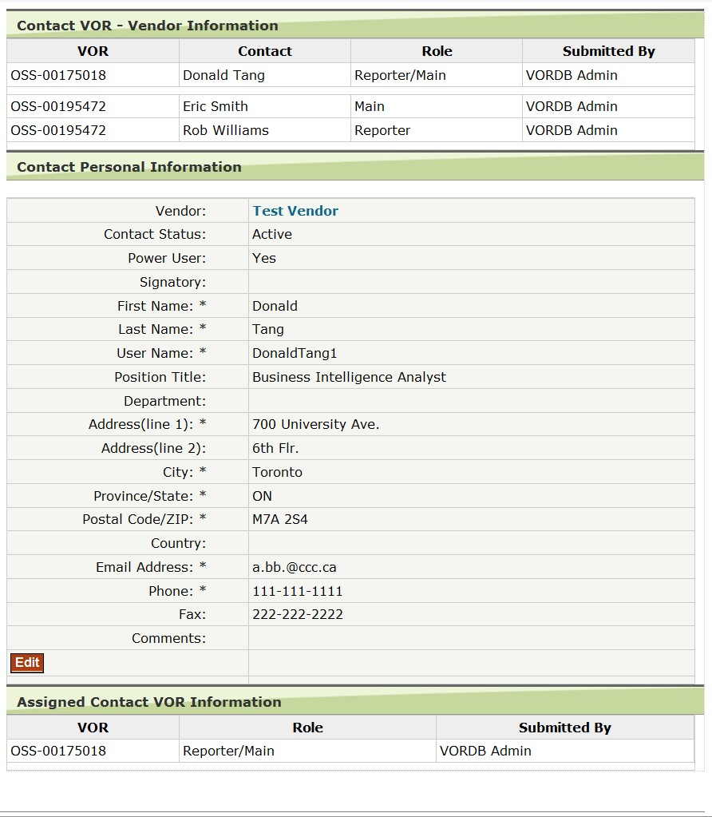**Assigned VOR #’s –** In order to change the assigned VORs and/or contact roles of this record go to the Contact-VOR section.

**Vendor –** The vendor’s name that the contact belongs to. To the vendor details page.

**Contact Status –** Default is “Active,” but if the individual is with your organization but not responsible for any VOR, then you can indicate that the contact is “Inactive.” If you wish to delete the contact, select “Archived.” (Please note that you will be unable to delete a contact if it is assigned a VOR responsibility. You must first delete the role(s), and then the contact)

**Power User –** If **Yes**, the user is able to retrieve and change passwords of their own account, edit contact details of their own and other contacts, or add and delete contacts for their organization.

If **No**, the user is only able to retrieve and change their own password, edit their own contact details, and delete their contact record.

**Signatory** – Indicate either “Mr.” “Ms.” or “Dr.” If none of these apply, then let the field remain blank. Not a mandatory field.

**First Name*/Last Name* –** If the contact has only one name, use a non-letter key in the First Name field (example: a non-letter key would be “*”)

**Username*:** a unique sequence of characters used to identify the user (vendor) and allow access to the Doing Business Portal.

**Position Title / Department** – Not mandatory fields.

**Address (line 1) * /Address (line 2) –** Insert street address for line 1 and floor number, suite number, etc. for line 2.

**City* –** Full names of cities or towns only. Abbreviations will not be accepted (example: N.Y. or T.O. is not an acceptable entry)

**Province/State* –** Abbreviations are preferred i.e., ON.

**Postal Code/ZIP* –** A1A 1A1 format for Canada, 11111 format for U.S.

**Country –** Necessary for U.S. organizations.

**Email Address* –** It is **mandatory** a vendor must ensure they maintain and keep the contact’s email address up to date in this database, as this will be the main source of contact with your organization. Vendor must provide the business email.

**Phone Number\*** – 111-111-1111 format.

**Fax Number** – 111-111-1111 format.

Fields with * beside them are mandatory.

## The Contact-VOR Section

This section is located at the bottom of the **Contact-VOR Info** Edit View on the Vendor Reporting Portal. Use this section to assign VOR responsibility and role to a contact. Your organization is limited to the VORs that you are listed under, and only one of each of the three responsibilities/roles can be used for active contacts for each VOR.

There are three types of responsibilities/roles (otherwise known as categories):

**Main** – This is the prime contact for your organization who manages communication with government contract manager at SCO and clients under a specific VOR agreement.

**Reporter** – Submits monthly reports (Usage Report or NIL Report) to SCO.

**Reporter/Main** – Fulfills the responsibility/role of both Main contact and the reporting requirements for the VOR.

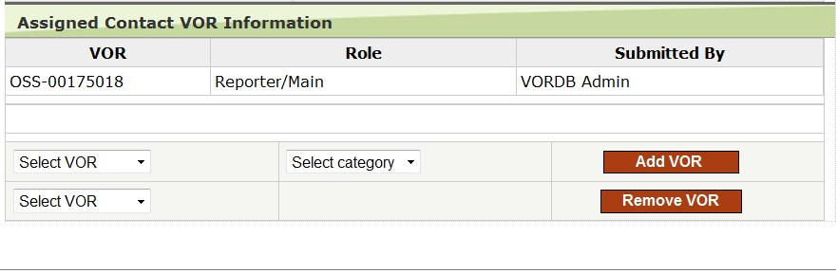

**There can be only one Main and one Reporter per VOR** that your organization is responsible for. These roles can be combined as the Reporter/Main but only one person can have this responsibility per VOR.

### Adding Responsibility/Role

To add VOR responsibility/role to one of your organization’s contacts please do the following:

1. Choose the contact’s name in the **Select Contact View**. When the contact page refreshes,click the **Edit** button.
2. At the bottom of the page, in the **Assigned Contact-VOR Information** section, choose the VOR that the contact is responsible for in the **Select VOR** dropdown.
3. Choose which responsibility/role the contact will be fulfilling for that VOR in the **Select Category** drop-down.
4. Press the **Add VOR** button.

The assigned VOR and responsibility/role will be added to the list. If you assigned too many contacts to one responsibility/role under a VOR, the message “**Selected VOR "VOR-###" is already assigned to this contact.**” will appear, and the responsibility/role will not be added to the list. You will need to unassign the responsibility/role first before adding anyone the responsibility/role.

will not be added to the list.

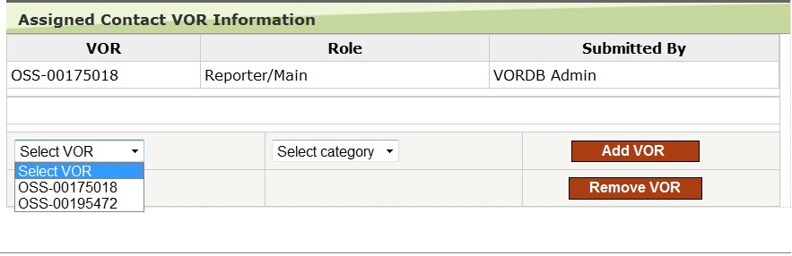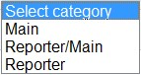

Select VOR & Select Category dropdowns Add VOR Button

### Removing Responsibility/Role

To remove a contact’s responsibility/role, select the VOR you wish to remove in the Select VOR dropdown, and click the Remove VOR button.

Remove VOR Button

Select VOR dropdown.

Remove

VOR Button

button

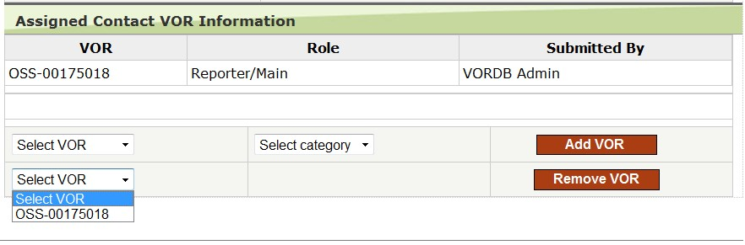

## Vendor Info

This link on the menu item of the Vendor Reporting Portal page displays your organization’s details as pertaining to the VORs that you are part of.

If you need to change any of these details, please contact the [Vendor Reporting Administrator](mailto:ppitpb.apts@ontario.ca).

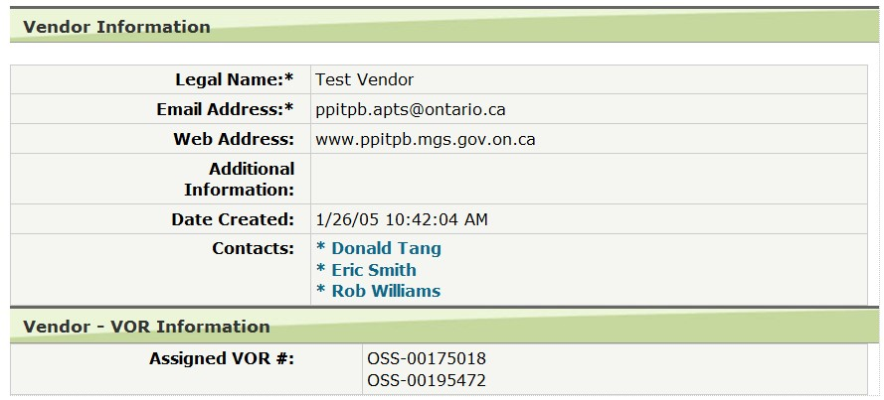**Legal Name** is your organization’s/companies name as it is listed on the VOR.

**Email Address:** is the vendors email address as listed on the VOR.

**Web Address:** is the vendors website.

Included: **Vendor-VOR Information, Assigned VOR #** are the SCO-VOR agreements on which your organization is listed.

## Submit Report

[The Vendor Reporting Portal](http://www.doingbusiness.mgs.gov.on.ca/mbs/psb/vordb.nsf) is the interface through which to submit SCO **Usage Report(s) or NIL Report(s)**. This link on the menu item of the Vendor Reporting Portal page displays Usage Reports (show contract business/usage on a VOR) are to be submitted using MS Excel templates which you can refer to Download template. Once filled out these templates are to be uploaded through the Vendor Reporting Portal.

Vendors who do not have business or usage in a given month are to submit a “NIL” Usage Report (i.e., “no new business that month”) which are submitted through the same uploading Portal.

Receipts of reporting submission is sent via email to the submitted reporter after each report is submitted through the website.

**Note:** Before reporting can be performed, a contact from your organization must be given responsibility for the VOR being reported and given the role of either Reporter/Main or Reporter. To assign responsibility, go to the Contact-VOR page. Please **make sure your email address is correct** in the Contact Info page, as this is where the web site will send you receipts for report submissions.

### Download Template

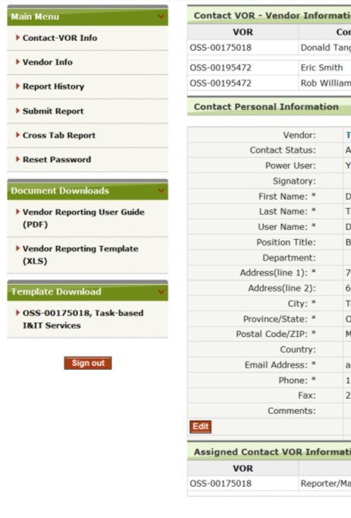

A Reporter is responsible to submit usage reports for each VOR they are responsible for. Some Reporters are responsible for submitting reports for multiple VORs.

**Attention:** It is recommended that you download a new VOR reporting template each time for reporting as these are often changed/updated.

To download a new reporting template for the VOR arrangement you are responsible for, you may download one from the home page of the Vendor Reporting Portal. On the left navigation pane, you will find the VOR reporting templates available to you under the Template Download section. Click on the link which shows the VOR number and name you are looking for and save the excel template after it loads into your browser.

Template Download Section

Reporters are required to always compare or download the current template versus the posted, as we often update the templates, so ensure you are using the most up to date version of the Reporting Template to report Usage.

### Submit Reports

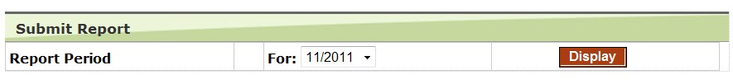

To submit a report, choose the reporting period from the drop-down box (the most current reporting period is the list box’s default) and click the **Display** button. The page will refresh to display a list of Usage Report(s) or NIL Report(s) previously submitted (with “NIL | Usage” on the same row).

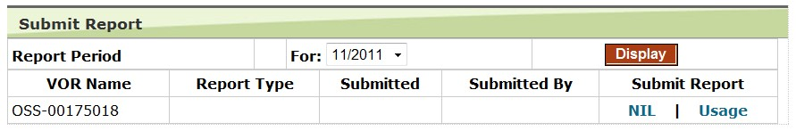

If you **do not** see a VOR name that should be available on this list, it is probably because responsibility for that VOR has not been assigned in the Contact-VOR Info page. Go to the Contact-VOR Info page, assign a user responsibility for reporting for the VOR in question, and return to the Submit Report page.

If you are submitting a Usage Report, click the **Usage link**.

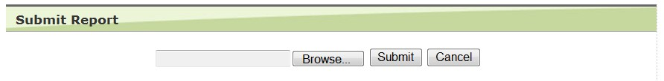

Click the **Browse** button to locate and upload the required month’s Usage report that you have completely filled out, and then click **Submit**.

**Reminder**: that you only report for the first month of a new transaction for the whole transaction (PO or SOW). In the second and continuous months if no new transaction (business) you would report Nil. The transaction is not split over months or years, it is reported only once in the first month. If there is an extension only the extension is reported in the first month. If there is NEW transaction(s), you would only report the new business or if there is an extension of a transaction (PO or SOW).

If you are submitting NIL, click the **NIL link to submit a NIL Report**.

### Receipt

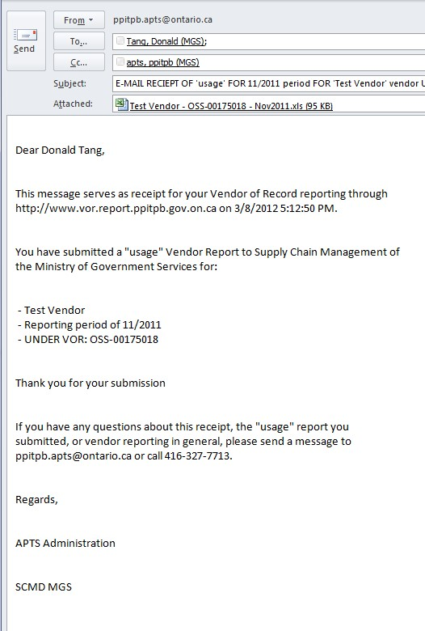An email receipt will be sent to your address. This receipt gives the details of your submission. If you reported multiple usage reports in the same report period transaction, all these usage reports will be listed on the receipt. If you do not receive a receipt, please check by Contact Info page to ensure that your email address is correct.

Another way to check which usage reports have been submitted is to go to the Reports History page and choose the reporting period(s) that the submitted reports should be in.

## Reports History

This link on the menu item of the Vendor Reporting Portal page is to view and download details about which Usage Report or NIL Reports your organization has submitted within a specified time frame.

### Review History

Choose the starting reporting period and the ending reporting period from the drop-down boxes and press the Display button. The page will refresh and present the reports you have submitted within the span of months chosen by you. The details will show the VOR, Year/Month period that had been reported, report type (Usage Report or Nil Report), the user who submitted the report, as well as the dates that the transactions have taken place.

If there is a discrepancy with the data provided, please contact the [Vendor Reporting Administrator](mailto:ppitpb.apts@ontario.ca).

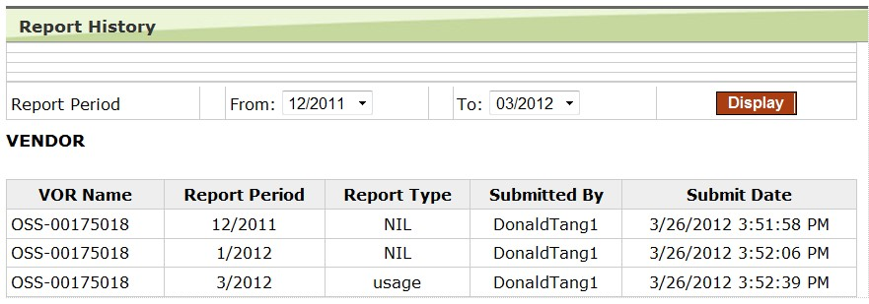

## Reset Password

This link on the menu item of the Vendor Reporting Portal takes users to where they can change their password.

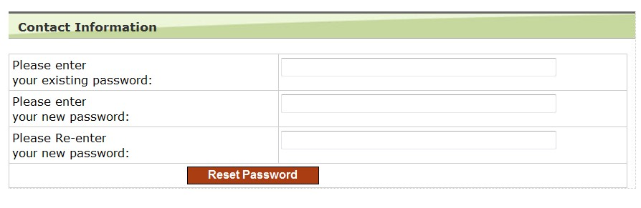Initially when you logon with a temporary password, this password is the “old password.”

If you forgot your password, click on the **Forgot Password** link on the home page. The new password will be sent to your email address, as shown in the Contact-VOR Info page.

## Appendix

## Step by Step Guides for Vendor Reporting Portal

### Basic Reporting Concepts:

You must report every month, regardless of whether there were any business/contracts (e.g., Purchase Orders (PO) or Statements of Works (SOW)) awarded during the previous month.

1. If there were business/awarded contracts, you fill out a Usage Template (excel) that can be downloaded from the Templates Download section of the Vendor reporting Portal. See below for instructions to upload the completed template into the Vendor Reporting Portal.
2. If there were no awarded contracts, see below to report NIL through the Vendor Reporting Portal.

### For Submitting Reports:

1. Log into the [Vendor Reporting Portal](http://www.doingbusiness.mgs.gov.on.ca/mbs/psb/vordb.nsf).
2. Click the Submit Report link in the Main Menu section.
3. **Select the month** you are reporting for in the Report Period dropdown and press the Display button.
4. If you see the message *“there are no active VORs…”*, then your account does not have the Reporter role that will allow you to submit reports. See The Contact-VOR Section for instructions on how to add/change contact roles.
5. *If you are submitting a Usage Report Template* (excel, .xlxs or.xls) for a VOR, **click on the Usage link in the row of the VOR you are reporting.**
6. **Press on the Browse button** to select the excel Report Template file from your computer.
7. **Press the Submit button**. Submission is complete, and an email receipt has been sent to you.
8. *If you are submitting a NIL report* for a VOR, **click on the NIL link in the row of the VOR you are reporting**. Submission is complete, and an email receipt has been sent to you.

### For Adding an Account (New Contact):

1. Log into the [Vendor Reporting Portal](http://www.doingbusiness.mgs.gov.on.ca/mbs/psb/vordb.nsf)
2. Click the Contact-VOR Info link in the navigation bar to the left.
3. Click the Add New Contact button.
4. Make sure you select the Power User “yes” radio button when creating a new account (this will allow the user to edit other contact records for your organization).
5. Enter all the needed information for the new contact in the Contact Info page and click on the Save button. *(An activation email will be sent to the account holders email address, with User ID and Password).*

### For Editing Contact Information:

1. Log into the [Vendor Reporting Portal](http://www.doingbusiness.mgs.gov.on.ca/mbs/psb/vordb.nsf)
2. Click the Contact-VOR Info link in the navigation bar to the left.
3. Click on your link (name).
4. Click on the Edit button at the bottom of the contact information.
5. Edit whatever information is needed to be changed.
6. Press the Save button.
7. Repeat steps 2 to 6 for any other contacts you wish to edit.

### For Deleting and Adding Contact VOR Responsibilities (Role):

(Switching responsibilities from one contact to another follow the full instructions below)

1. Log into the [Vendor Reporting Portal.](http://www.doingbusiness.mgs.gov.on.ca/mbs/psb/vordb.nsf)
2. Click on the Contact-VOR Info link in the main menu.

### Removing VOR Responsibility (Role):

1. Click on the link (name) of the contact who will have the role removed.
2. Click on the Edit button near the bottom of the webpage.
3. In the last dropdown at the bottom of the webpage, choose one of the VORs this contact is responsible for.
4. Click the Remove VOR button.
5. Click the Save button.
6. Repeat steps 5 to 8 for any additional VOR removals.
7. If this contact is to be changed from a ‘Reporter/Main’ to a ‘Main’ role (or vice versa), add the Main role by following steps 13 to 16.
8. Click the Contact-VOR Info link in the navigation bar to the left.

### Adding VOR Responsibility (Role):

1. Click on the link (name) of the contact who will have the role added.
2. Click on the Edit button.
3. In the second last dropdown choose a VOR.
4. In the dropdown to the right of the VOR dropdown, choose a role (for Reporting, it will be either 'Reporter/Main' or 'Reporter').
5. Click on the Add VOR button.
6. Click the Save button.
7. Repeat steps 13 to16 for any additional VOR additions.

### For Changing VOR Responsibility (Role):

1. Click on the link (name) of the contact who will have the role changed.
2. Click on the Edit button near the bottom of the webpage.
3. In the last 'Select VOR' dropdown at the bottom of the webpage, choose a VOR.
4. Click the Remove VOR button.
5. Click the Save button.
6. In the second last 'Select VOR' dropdown, choose a VOR.
7. In the 'Select Category' dropdown, choose "[Main] or [Reporter] or [Reporter/Main]."
8. Press the Add VOR button.
9. Press the Save button.

### For Archiving (Deleting) a Vendor Contact:

1. Log into the [Vendor Reporting Portal](http://www.doingbusiness.mgs.gov.on.ca/mbs/psb/vordb.nsf)
2. Click the Contact-VOR Info link in the navigation bar to the left.
3. Click on your link (name).
4. Click on the Edit button at the bottom of the contact information.
5. In the Contact Status field of the same page, choose the Archive radio button.
6. Click the Save button.